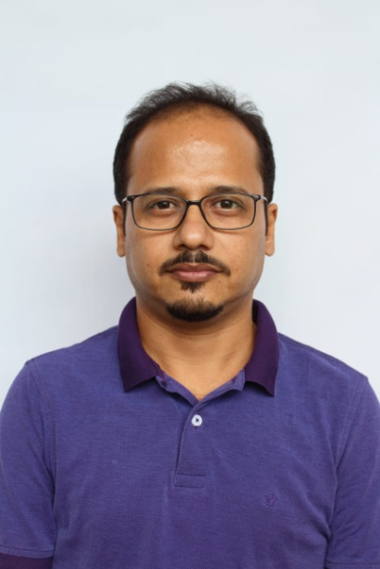

Dr. Pinak Dutta
Associate Professor
Department of Chemistry
Bejoy Narayan Mahavidyalaya
Itachuna, Hooghly, PIN 712147
Email id: pimidu@yahoo.com
pinak@bnmv.ac.in
Ph: 9433754969

______________________________________________________________________________

After graduating from Hooghly Mohsin College with Honours in Chemistry as Burdwan University Topper he completed his Masters from the same University as an overall Topper in 1996. He earned his Ph.D. from Indian Association for the Cultivation of Science (IACS) , Kolkata, under the able guidance of Professor B. C. Ranu and he also had the opportunity to work under Professor Subhash Chandra Ray. In 1997 he was awarded the Ronit Pratibha Puraskar.
His research interest includes synthetic methodology, natural product chemistry, pollution chemistry and green chemistry. He has more than 20 publications in reputed journals to his credit.
He also had the opportunity to work with Professor Gilles Dujardin and Professor Eric Brown at the Universite du Mainé (Le Mans University), France.
Beside his academic aspect he is an excellent wildlife Photographer whose pictures have been published in magazines of National repute like ‘Bhraman’, ‘Sanctuary Asia’ and ‘Saevus’. In 2016, he was a proud second runner up of a photography contest organised by Nikon India and in 2021 he was among the top 10 best photographer in the contest jointly organized by Rajasthan University of Veterinary & Animal Sciences, Directorate of Human Resources Development CSWMH, Bikaner & WWF India Udaipur Division to celebrate "World Wetland Day - 2021".
He is also an ardent birder, avid traveller and a certified scuba diver.

